Design of GUVI Database

1. 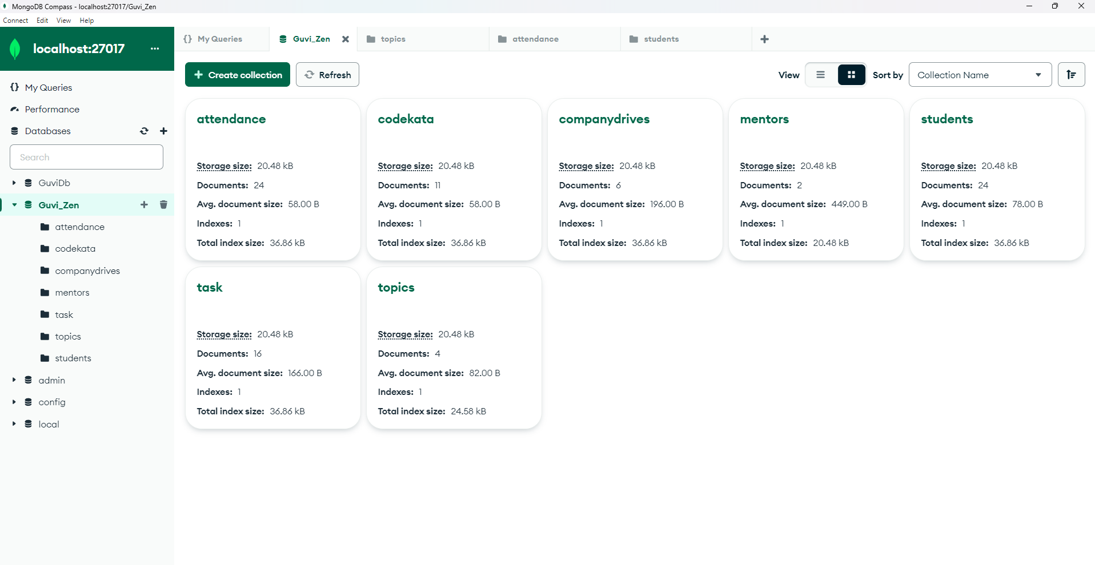Find all the topics and tasks which are thought in the month of October

db.topics.aggregate([

{

$lookup: {

from: "task",

localField: "_id",

foreignField: "topicId",

as: "Taskinfo"

}

},

{

$match: {

$and: [

{

conducted_on: {

$gte: new Date("01-10-2023"),

$lt: new Date("01-11-2023")

}

},

{

$or: [

{

"taskinfo.deadline": {

$gte: new Date("15-10-2023"),

$lt: new Date("01-11-2023")

}

},

{

"taskinfo.deadline": {

$exists: false

}

}

]

}

]

}

},

{

$project: {

_id: 0,

topicId: 1,

title: 1,

conducted_on: 1,

task: "$taskinfo.title",

deadline: "$taskinfo.deadline"

}

}

])

1. Find all the company drives which appeared between 15 oct-2020 and 31-oct-2020?

db.companydrives.find

({ $or:[{drive_date:{$gte: new Date(“15-10-2020”)}},

{drive_date:{$lte: new Date(“31-10-2020”)}}

]})

1. Find all the company drives and students who are appeared for the placement.

db.companydrives.aggregate([{

$lookup:{

from:"users",

localField:"attended_by",

foreignField:"_id",

as:"userinfo"}},

{$project:{

_id:0,

name:1,

drive_date:1,

students:"$userinfo"}}])

1. Find the number of problems solved by the user in codekata?  
   db.codekata.aggregate.([{$lookup:{

from:"students",

localField:"userId",

foreignField:"_id",

as:"userinfo"}},

{

$group:{_id:{userid:"$userId", username:"$userinfo.name"}, totalproblemssolved:{$sum:"$prblmno"}},{

$project:{

_id:0,

userid:"$_id.userId",

username:"$_id.username",

totalproblemssolved:1}}}])

1. Find all the mentors with who has the mentee's count more than 15?  
   db.mentors.aggregate([

{

$addFields: {

numMentees: { $size: "$mentees" }

}

},

{

$match: {

numMentees: { $gt: 15 }

}

},

{

$project: {

name: 1,

numMentees: 1,

_id: 0

}

}

])

1. Find the number of users who are absent and task is not submitted  between 15 oct-2020 and 31-oct-2020

db.attendance.aggregate([

{$lookup:

{

from:"tasks",

localField:"topicid",

foreignField:"topicId",

as:"tasks"

}

},

{$match:

{attended:false,

"tasks.submitted": false,

$and:[{

"tasks.deadline":{$gte: new Date("15-oct-2020")}},

{"task.deadline":{$lte: new Date("31-oct-2020")}}

]}},

{$count:"No.of_Students_absent"}])